SIMATS ENGINEERING (SAVEETHA SCHOOL OF ENGINEERING)
Department of Computer Science and Engineering
CO2 ASSESSMENT TOOL 1 – Scenario-Based Requirement Analysis

Course Code: | CSA1007 | Course Title: | Software Engineering
CO Assessed: | CO2 | Assessment: | Assessment Tool 1 – Scenario-Based Requirement Analysis
Weightage: | 20% | Total Marks: | 25
CO2 Statement: | Perform detailed requirements analysis, design scalable architectures, and prioritize features with a focus on cross-disciplinary skills
Student Name: | MEGALA.P | Reg. No.: | 192573019
Date: | 28/7/26 | Duration: | 60 minutes

Code of Conduct
I Megala.P(192573019) (Name / Reg No) certify that this submission is my original work and that I have adhered to the guidelines specified for this assessment. I understand that any violation of academic integrity rules will result in disciplinary action.
Signature of the Student: Megala.P
Annexure A – Scenario-Based Requirement Analysis
Instructions to Students:
Each student will be assigned an individual software project problem statement. Analyze the given scenario and prepare a complete Software Requirement Analysis document by following the steps below.

Question
Based on the assigned problem statement, perform a Scenario-Based Requirement Analysis and prepare a Software Requirement Specification (SRS) document. Your analysis should include the following:
- Study and Analyze the Scenario
  - Carefully understand the given problem statement.
  - Identify the business domain, stakeholders, existing challenges, and system objectives.
- Identify Functional and Non-Functional Requirements
  - List all functional requirements required by the proposed system.
  - Identify suitable non-functional requirements such as performance, security, reliability, usability, scalability, maintainability, and availability.
- Identify Actors and Use Cases
  - Identify all primary and secondary actors interacting with the system.
  - List the major use cases associated with each actor.
  - Draw a Use Case Diagram representing the interactions between actors and the system.
- Prepare the Software Requirement Specification (SRS)
Develop an SRS document containing:
  - Introduction
  - Problem Description
  - Scope of the System
  - Functional Requirements
  - Non-Functional Requirements
  - Use Case Descriptions
  - Data Requirements
  - External Interface Requirements
  - System Features
- Identify Assumptions and Constraints
  - List the assumptions considered while developing the system.
  - Identify technical, operational, economic, legal, and time-related constraints affecting the project.
- Validate Requirement Completeness and Consistency
  - Verify whether all stakeholder requirements have been addressed.
  - Check for ambiguity, redundancy, inconsistency, and missing requirements.
  - Suggest improvements to enhance the quality and completeness of the requirement specification.
Rubrics for Calculation
Criteria | Excellent (4 Marks) | Good (3 Marks) | Satisfactory (2 Marks) | Needs Improvement (1 Mark)
Scenario Understanding and Problem Analysis | Demonstrates thorough understanding of the scenario, stakeholders, objectives, and business context with clear analysis. | Demonstrates good understanding with minor omissions. | Basic understanding with limited analysis. | Poor understanding; major aspects missing or incorrect.
Functional and Non-Functional Requirement Identification | Clearly identifies comprehensive, accurate, and well-classified functional and non-functional requirements. | Identifies most requirements with minor classification errors. | Identifies only basic requirements; several omissions. | Requirements are incomplete, inaccurate, or poorly classified.
Actor Identification and Use Case Modeling | Correctly identifies all relevant actors and use cases; use case diagram is complete, accurate, and follows UML standards. | Most actors and use cases identified; diagram has minor errors. | Limited actors/use cases identified; diagram partially correct. | Actors/use cases missing or incorrect; diagram absent or inaccurate.
Software Requirement Specification (SRS) Documentation | SRS is well-structured, complete, professionally organized, and includes all required sections. | SRS is organized with minor missing sections or formatting issues. | SRS includes only essential sections with limited detail. | SRS is incomplete, poorly organized, or lacks essential components.
Assumptions, Constraints, and Requirement Validation | Clearly identifies realistic assumptions and constraints; validates requirements for completeness, consistency, and ambiguity with appropriate justification. | Identifies most assumptions and constraints; validation is adequate. | Limited assumptions/constraints; validation is superficial. | Assumptions, constraints, and validation are missing or incorrect.

Criteria | Mark
Scenario Understanding and Problem Analysis | /5
Functional and Non-Functional Requirement Identification | /5
Actor Identification and Use Case Modeling | /5
Software Requirement Specification (SRS) Documentation | /5
Assumptions, Constraints, and Requirement Validation | /5
TOTAL | /5

Scenario-Based Requirement Analysis
Factory Energy Monitoring and Machine Utilization Optimization System
NAME: MEGALA.P SLOT:D
REG NO:192573019 COURSE CODE: CSA1007
Software Requirement Specification (SRS)
1. Introduction
The Factory Energy Monitoring and Machine Utilization Optimization System is a cloud-based industrial automation solution that monitors factory energy consumption and machine utilization in real time using IoT devices, AI/ML, and cloud computing. The system collects operational data from machines and sensors, analyzes performance, detects abnormalities, predicts equipment failures, and provides alerts and reports. It helps industries reduce downtime, save energy, improve productivity, and make better operational decisions.
2. Problem Description
Traditional factories rely on manual monitoring and reactive maintenance, which leads to high energy consumption, unexpected machine failures, production delays, increased maintenance costs, and poor resource utilization. There is no centralized platform to monitor machine performance or energy usage across multiple factory locations.
The proposed system provides continuous monitoring, predictive maintenance, intelligent analytics, and automated notifications to improve operational efficiency and reduce operational costs.
3. Scope of the System
The system will:
- Collect real-time data from IoT sensors.
- Monitor machine health and utilization.
- Measure factory energy consumption.
- Detect abnormal operating conditions.
- Predict machine failures using AI/ML.
- Send instant alerts to stakeholders.
Functional Requirements
- Predict Machine Failures
- Generate Real-Time Alerts User Login and Authentication
- Manage Users and Roles
- Collect Real-Time IoT Sensor Data
- Monitor Machine Status
- Monitor Energy Consumption
- Detect Machine Anomalies
- Generate Daily, Weekly and Monthly Reports
- Display Live Dashboard
- Store Historical Data
- Export Reports (PDF/Excel)

Non-Functional Requirements
Performance
- Dashboard response within 3 seconds.
- Real-time monitoring every second.
Security
- User authentication.
- Role-based access control.
- Encrypted communication.
Reliability
- 99.9% uptime.
- Automatic backup and recovery.
Scalability
- Supports multiple factories and thousands of IoT devices.

Availability
- 24×7 system operation.
Usability
- Easy-to-use web dashboard.
- Mobile-friendly interface.
Maintainability
- Modular software architecture.
- Easy software updates.

Actors
Primary Actors
- Factory Manager
- Maintenance Engineer
- Energy Manager
- Machine Operator
- Administrator
Secondary Actors
- IoT Sensors
- AI Prediction Engine
- Cloud Database
- Notification Service
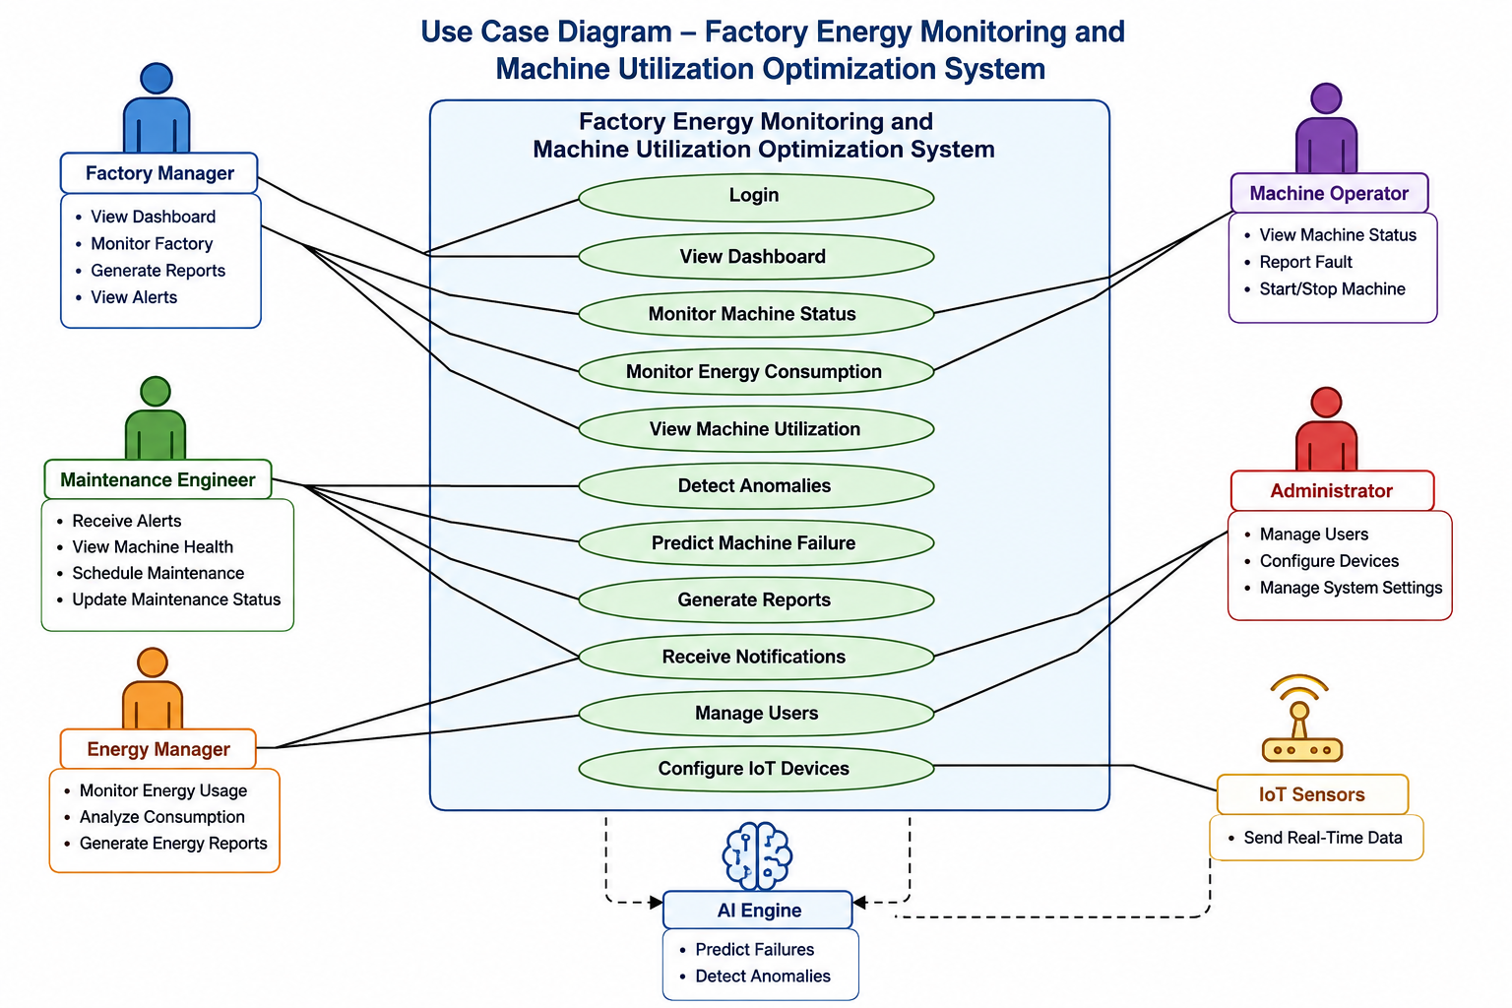

Major Use Cases
Actor | Use Cases
Factory Manager | View Dashboard, Monitor Factory, Generate Reports, View Alerts
Maintenance Engineer | View Machine Health, Receive Alerts, Schedule Maintenance
Energy Manager | Monitor Energy Usage, Analyze Consumption, Generate Energy Reports
Machine Operator | View Machine Status, Report Fault
Administrator | Manage Users, Configure Devices
IoT Sensors | Send Real-Time Data
AI Engine | Detect Anomalies, Predict Machine Failure

Use Case Description
Use Case: Monitor Machine Status
Actor: Factory Manager
Precondition: User must be logged in.
Flow:
- Select machine.
- View live status.
- View utilization percentage.
- View energy consumption.
Post Condition
Machine information is displayed successfully.

Use Case: Predict Machine Failure
Actor: AI Engine
Flow
- Collect sensor data.
- Analyze historical data.
- Detect abnormal patterns.
- Predict possible failure.
- Send alert to maintenance engineer.

Data Requirements
Input Data
- Temperature
- Voltage
- Current
- Vibration
- Power Consumption
- Machine Status
- Running Hours
Output Data
- Dashboard
- Alerts
- Reports
- Failure Predictions
- Machine Utilization Report
- Energy Consumption Report

External Interface Requirements
Hardware
- IoT Sensors
- Smart Energy Meter
- PLC Controller
- Temperature Sensor
- Vibration Sensor
Software
- Cloud Database
- AI/ML Engine
- Email Service
- Notification API

Communication
- MQTT
- HTTP/HTTPS
- Wi-Fi
System Features
- Real-Time Monitoring
- AI-Based Prediction
- Energy Analytics
- Machine Utilization Tracking
- Automated Alerts
- Dashboard
- Report Generation
- Multi-Factory Support
- Historical Data Analysis
- Cloud Storage

Assumptions
- IoT devices are installed correctly.
- Stable internet connection is available.
- Users are trained to operate the system.
- Cloud services remain available.

Constraints
Technical
- IoT sensor compatibility.
- Internet dependency.
Economic
- Hardware installation cost.
- Cloud subscription cost.
Operational
- Continuous power supply.
- Regular sensor maintenance.

Legal
- Data privacy regulations.
- Industrial safety standards.
Time
- Limited project development schedule.

Requirement Validation
- All stakeholder requirements are identified.
- Functional and non-functional requirements are complete.
- No ambiguity or redundancy exists.
- The system is scalable, secure, and reliable.
- Future enhancements may include carbon emission monitoring and digital twin technology.

Conclusion
The Factory Energy Monitoring and Machine Utilization Optimization System provides a smart, scalable, and secure solution for modern industries. By integrating IoT, cloud computing, and AI/ML, it enables real-time monitoring, predictive maintenance, efficient energy management, and optimized machine utilization. The system improves operational efficiency, reduces downtime and costs, enhances decision-making, and supports large-scale industrial deployment.

